74 Peter St
Grovedale
Victoria, Australia 3216

phone 0011 61 418 561 796
email rettaust@bigpond.com
websites:
RSAA http://www.rettaustralia.com
World Congress http://rettworldcongress.org/

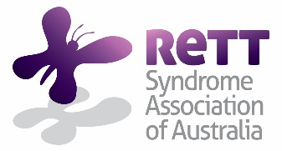

Caroline Lietaer
President
Rett Syndrome Europe

Dear Caroline and members of Rett Syndrome Europe,

Re: 9th World Rett Syndrome Congress
Gold Coast, Queensland - 30 September to 3 October 2020

The Rett Syndrome Association of Australia (RSAA) first mooted the suggestion that the 9th World Rett Syndrome Congress take place in Australia at the RTT 50.1 conference held in Vienna in September 2016, an event which marked the 50th anniversary of the first publication on Rett syndrome. Later, at Rett Syndrome Europe’s Congress in Berlin (2017) and this year’s international Rett syndrome conference in Rome, RSAA again let it be known that it was willing to stage the event. A positive response was received on both those occasions and what with, to our knowledge, no other Rett syndrome Association actively seeking to do likewise, RSAA has committed to running with it.

Our Association views the occasion as being an event for all those involved with Rett syndrome, be they scientists or not, be they attending or not, regardless of where they are located in the world. Therefore, we are hoping that Rett Syndrome Europe can include a copy of this letter not only on its website but also ask its members if they could do the same on their national Association sites. Their individual responses would be most welcome.

What might one’s involvement be, other than being at the Congress in person?
Presenters
Most importantly, RSAA is looking for potential presenters by tapping into the local knowledge of member Associations. We would welcome the names, contact details and specialities of those persons in your part of the world, whom it is strongly felt would have something to present which would be of benefit to those involved with Rett syndrome. They can be scientists, therapists, parents, teachers, or anyone else for that matter, whom it is felt would have something significant to offer Rett syndrome individuals, their families and others interested in the disorder.

Programme
At this point in time, it is our aim to have the content applicable to both scientist and non-scientist. Both streams would run concurrently, with the former probably spanning two days and the latter, three and a half days. The content will contain familiar topics and hopefully, include some topics which are usually not in the limelight at Rett syndrome conferences but which might deserve attention. Any thoughts on the latter?

Raising awareness
If your Association/group can play a role in staging the Congress by informing others in your part of the world that it will soon be taking place, then we encourage you to go for it.

1

What with the distances involved in getting to and from Australia, the time that it takes and
the expense, RSAA, in the past, has been very reluctant to stage a World Congress. We appreciate
that for those who live overseas and wish to attend, it is a considerable effort for them to do so.
Maybe incorporating attendance at the World Congress while holidaying in Australia, could be an option. Even so, we now feel that the time is right for us to bring the Congress to the southern hemisphere for the first time. If Rett Syndrome Europe member Associations can play a part, the
better the Congress will be. Needless to say, we hope that some of those who support their national Association/group, will make the journey downunder.

In the meantime, RSAA believes that it is important to have other Rett Associations/groups actively involved in the lead-up to the 9th World Congress Rett Syndrome to take place here in 2020. If you have any comments in regard to presenters, content and/or raising awareness, please get back to me by
by 28 February 2019. Thank you.

We have created a Congress website at http://rettworldcongress.org to which information that you will need to know, will be added progressively. Hopefully, this letter will be viewed by those who read it as an opportunity to participate in the staging of the 9th World Congress on Congress.

May this time of year be an enjoyable for you, your families and those whom you seek to help,

Bill Callaghan
Vice-President
Rett Syndrome Association of Australia Inc.
17 December 2018

Congress location - Surfers Paradise on the Gold Coast (looking north), Australia
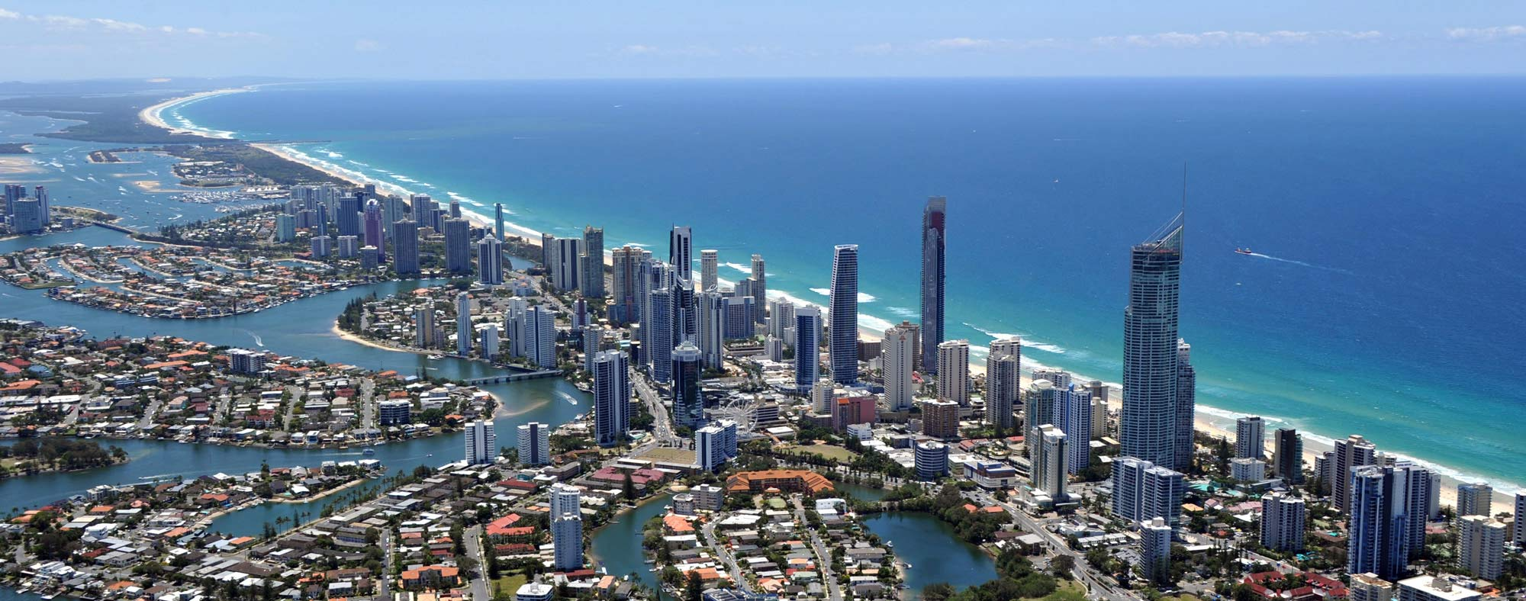

2

